C break statement

The break is a keyword in C which is used to bring the program control out of the loop. The break statement is used inside loops or switch statement. The break statement breaks the loop one by one, i.e., in the case of nested loops, it breaks the inner loop first and then proceeds to outer loops. The break statement in C can be used in the following two scenarios:

1. With switch case
2. With loop

Syntax:

1. //loop or switch case
2. **break**;

Flowchart of break in c

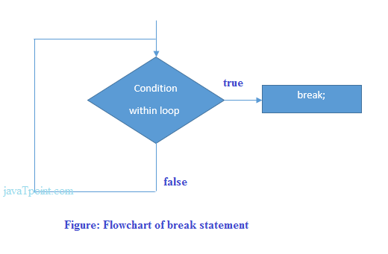

Example

1. #include<stdio.h>
2. #include<stdlib.h>
3. **void** main ()
4. {
5. **int** i;
6. **for**(i = 0; i<10; i++)
7. {
8. printf("%d ",i);
9. **if**(i == 5)
10. **break**;
11. }
12. printf("came outside of loop i = %d",i);
14. }

**Output**

0 1 2 3 4 5 came outside of loop i = 5

Example of C break statement with switch case

Click here to see the example of [C break with the switch statement](https://www.javatpoint.com/c-switch).

C break statement with the nested loop

In such case, it breaks only the inner loop, but not outer loop.

1. #include<stdio.h>
2. **int** main(){
3. **int** i=1,j=1;//initializing a local variable
4. **for**(i=1;i<=3;i++){
5. **for**(j=1;j<=3;j++){
6. printf("%d &d\n",i,j);
7. **if**(i==2 && j==2){
8. **break**;//will break loop of j only
9. }
10. }//end of for loop
11. **return** 0;
12. }

**Output**

1 1

1 2

1 3

2 1

2 2

3 1

3 2

3 3

As you can see the output on the console, 2 3 is not printed because there is a break statement after printing i==2 and j==2. But 3 1, 3 2 and 3 3 are printed because the break statement is used to break the inner loop only.

break statement with while loop

Consider the following example to use break statement inside while loop.

1. #include<stdio.h>
2. **void** main ()
3. {
4. **int** i = 0;
5. **while**(1)
6. {
7. printf("%d  ",i);
8. i++;
9. **if**(i == 10)
10. **break**;
11. }
12. printf("came out of while loop");
13. }

**Output**

0 1 2 3 4 5 6 7 8 9 came out of while loop

break statement with do-while loop

Consider the following example to use the break statement with a do-while loop.

1. #include<stdio.h>
2. **void** main ()
3. {
4. **int** n=2,i,choice;
5. **do**
6. {
7. i=1;
8. **while**(i<=10)
9. {
10. printf("%d X %d = %d\n",n,i,n*i);
11. i++;
12. }
13. printf("do you want to continue with the table of %d , enter any non-zero value to continue.",n+1);
14. scanf("%d",&choice);
15. **if**(choice == 0)
16. {
17. **break**;
18. }
19. n++;
20. }**while**(1);
21. }

**Output**

2 X 1 = 2

2 X 2 = 4

2 X 3 = 6

2 X 4 = 8

2 X 5 = 10

2 X 6 = 12

2 X 7 = 14

2 X 8 = 16

2 X 9 = 18

2 X 10 = 20

do you want to continue with the table of 3 , enter any non-zero value to continue.1

3 X 1 = 3

3 X 2 = 6

3 X 3 = 9

3 X 4 = 12

3 X 5 = 15

3 X 6 = 18

3 X 7 = 21

3 X 8 = 24

3 X 9 = 27

3 X 10 = 30

do you want to continue with the table of 4 , enter any non-zero value to continue.0